Mercian Clothing Catalogue
2022

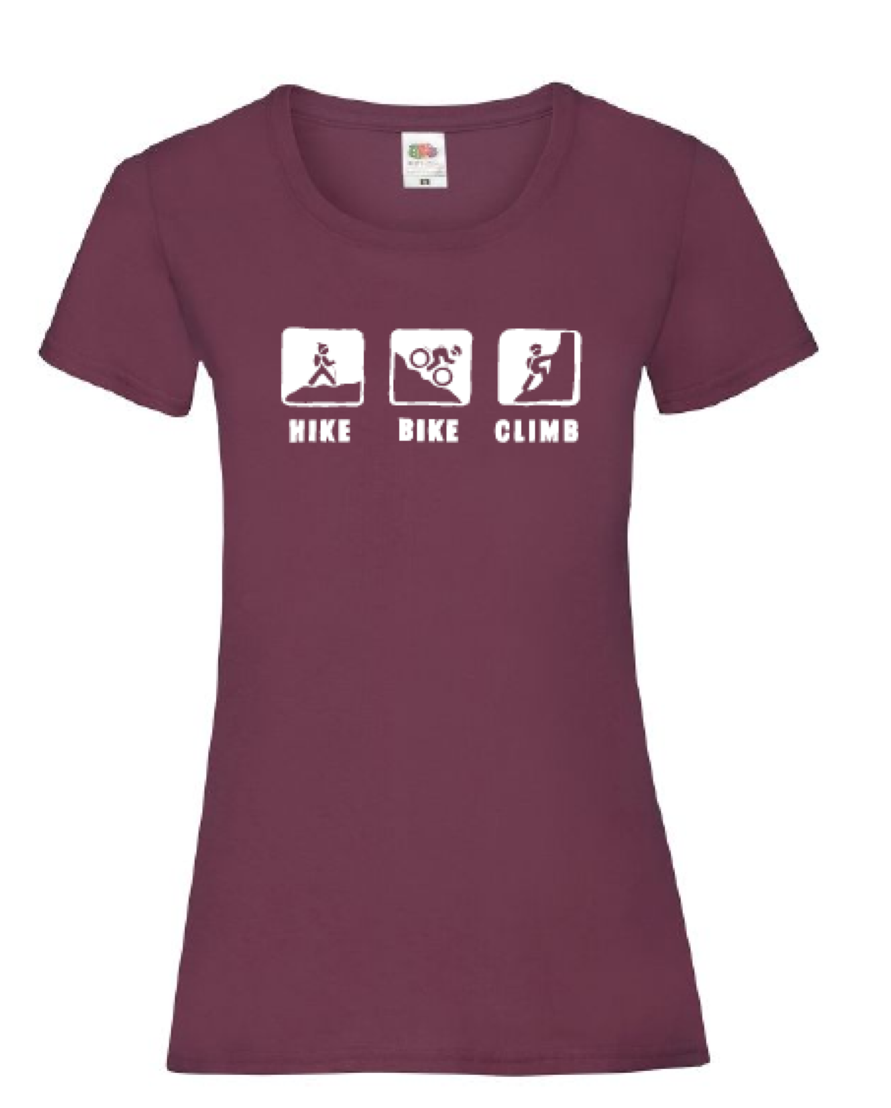
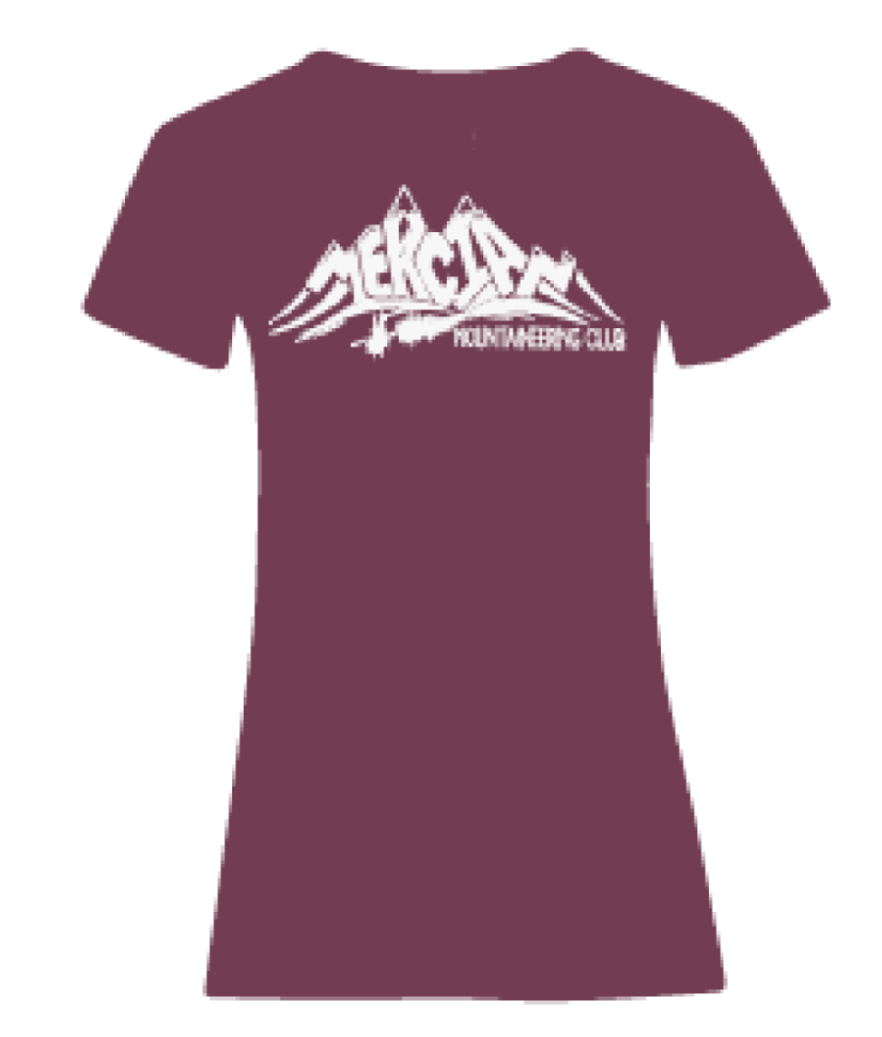
Garment | Size | Estimated price
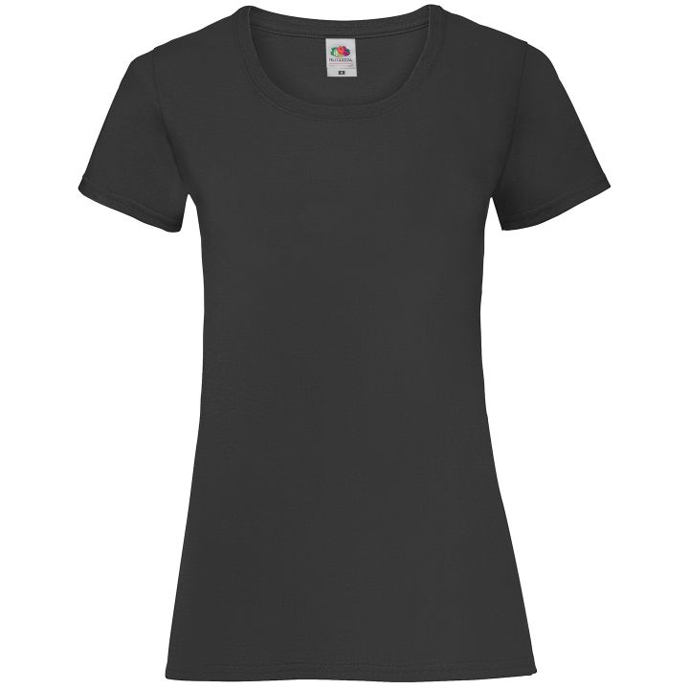Lady’s T-shirt | XS - 8  S - 10  M - 12  L - 14  XL - 16  2XL - 18 | £18.75  £15.80 (10 or more)  £13.15 (25 or more)
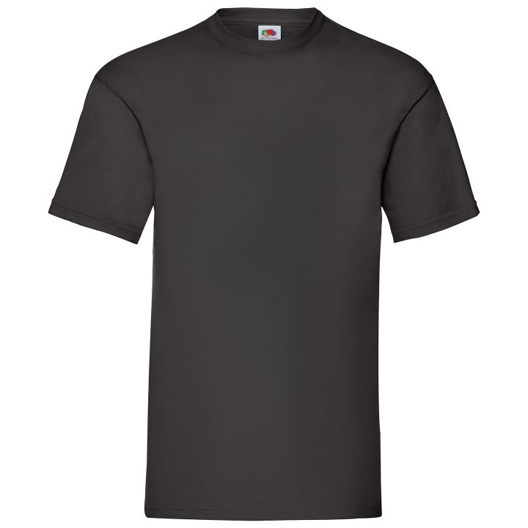Men’s T-Shirt | S - 35-37"  M - 38-40"  L - 41-43"  XL - 44-46"  2XL - 47-49"  3XL - 50-52" | £18.50  £15.60 (10 or more)  £12.95 (25 or more)
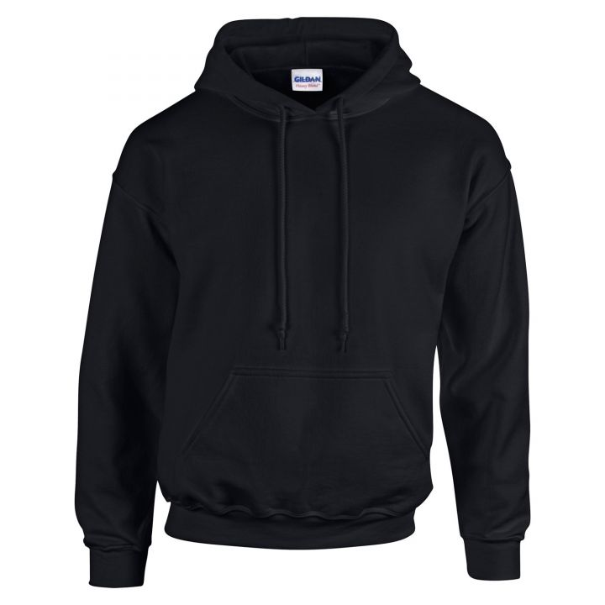Unisex Hoodie | XS - 32-34"  S - 34-36"  M - 38-40"  L - 42-44"  XL - 46-48"  2XL - 50-52"  3XL - 54-56"  4XL - 58-60" | £35.15  £32.75 (10 or more)  £24.19 (25 or more)
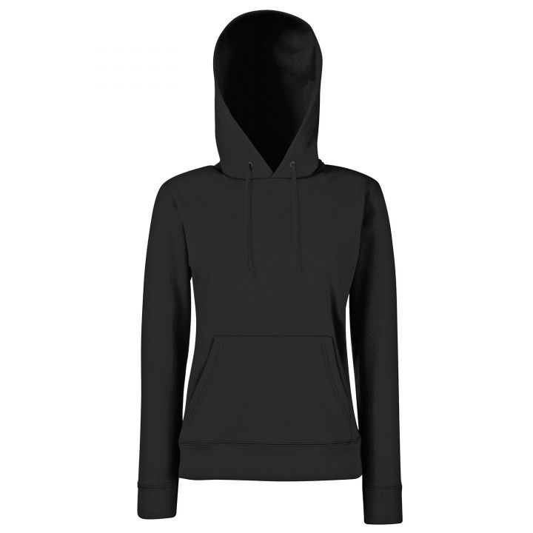Lady’s Hoodie | XS - 8  S - 10  M - 12  L - 14  XL - 16  2XL - 18 | £36  £33.65 (10 or more)  £29.70 (25 or more)



